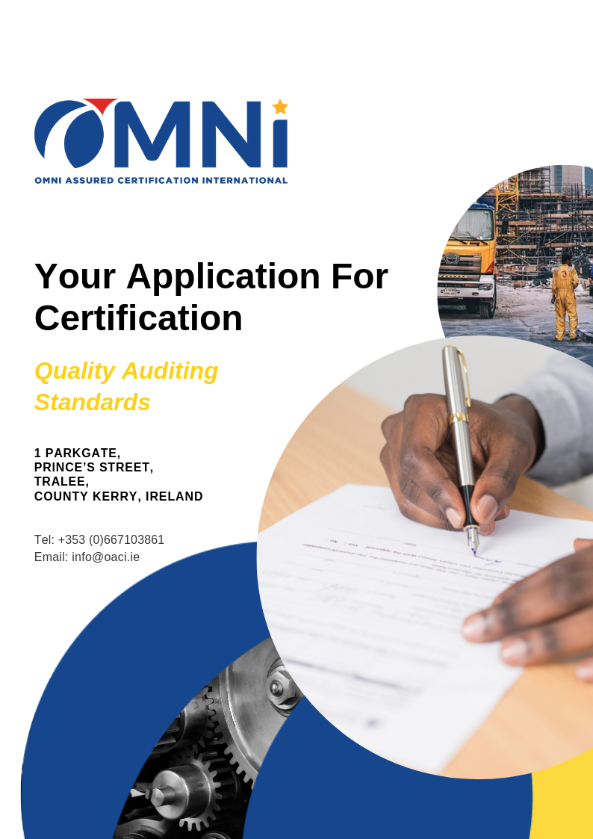
Tel: +353 (0) 67 50298
E: info@oaci.ie
W: www.oaci.ie

40 Pearse Street
Nenagh
Co. Tipperary
Ireland

Please provide as much detail as possible on this form to enable us to deliver the best possible quote and customer service to your organisation

How/where did you hear about us?
Date Application Completed

General Organisation Details
Registered Name
Full Address
Website
Telephone
Email
Organisation VAT Number

Organisation Key Contact Details
Key Contact Name
Key Contact Role Title
Key Contact Telephone
Key Contact Email

Marketing Permissions
Do you consent to the use of your company data in the promotion and advertising of OMNI’s services?
For example, we intend to post updates on LinkedIn of the companies we have certified along with news items and case studies on our website and other media platforms.
Yes, I/we consent

No, I/we do not consent

Required Certification Details
ISO 9001
ISO 14001
ISO 45001
Is your system fully integrated with other standards, if so, please provide details | Yes  No  Details:
Do you require a commitment certificate as evidence of your application for certification(s)? | Yes  No

Certification Scope Details
Please provide a brief description of the operational activities, services etc. to be certified
Please provide details of any design services undertaken by your organisation in relation to product and service design
Please provide details of any outsourced functions
Please provide details of the sectors or key organisations you provide services to

Personnel Details
Please provide a figure for the total FTE personnel employed
Please provide details of the number of shifts you operate
Please provide details of any remote workers employed
Please provide details of any temporary workers employed
Please provide details of any personnel performing similar roles within the organisation | e.g. 10 security guards, 50 drivers, 200 cleaners 20 administrators, 30 technicians etc.

Location Details
Please provide details of the number of permanent locations your organisation operates from
Please provide details of the full addresses of all permanent locations your organisation operates from
Please provide details of the average number of temporary or customer locations you operate from at any time

Impartiality Details
Please provide details of any consultants who have assisted you in achieving conformance with the standard requirements against which you require certification
Please provide details to the best of your knowledge of any services you have prior received from anyone involved in the certification activities of OMNI for whom this may create a conflict of interest
Please provide details of any other potential threat to the impartiality and integrity of OMNI processes and procedures for certification

Additional Information
Please provide details of any additional details which may assist our auditor in carrying out your certification audit
(e.g. dangerous animals; PPE requirements; interpreter(s) required; security requirements; induction requirements; special requests or requirements; or, any other health and safety risks not covered)
Please provide details of any additional high-level regulation or standard requirements placed upon your organisation affecting the audit; your preparedness; or the audit outcome
Finally, please provide any additionally relevant details which you feel have not yet been covered

Management System Details
Have you developed your Documentation for your Management system? | Yes  No
If applicable, how long has your current Management system been in place?
Does your company’s quality manual fully address ISO9001: 2015? | Yes  No
Are there any claimed exclusions from Clause 7 of ISO9001:2015? | Yes  No
If Yes, what are the exclusions and how are they justified?
Have you conducted Internal Audit & Management Review? | Yes  No
Please select the Documents you have in place | Management System Manual  Quality/ Management/ Health & Safety Policy & Objectives  Latest Internal Audit Report  Management Review Report

ISO 14001 Additional Information
Have the environmental aspects applicable to the organisation been identified? | Details:
Are there any Environmental issues facing the company (Management View)? | Yes  No
Does the organisation operate in any environmentally sensitive areas? | Details:
Do you rent or share any of your premises? | Details:
Are any of your sites subject to environmental permits, licences or consents? | Details:
Has your organisation ever been prosecuted for a breach of any kind relating to environmental infringements? | Details:
Are Site Plans (including Drainage System) available for the site? | Yes  No
Sensitivity of audit site (Interest groups, high regulations, populations, etc) | Details:
List of chemicals/ materials used in the site/ facility. Detail Hazardous Waste Management | Details:
Detail significant utilities used in the site/ facility (Gas, Electric, Water, Oil…) | Details:
Details of Waste Management (Effluent treatment/ discharge, solid waste management, etc) | Details:
Details of outsourced processes significant to the environmental management (Outsourced effluent processing, waste disposal, etc) | Details:

ISO 45001 Additional Information
Outline processes within the scope of OH&S System | Details:
What legislation, regulations and applicable guidance apply to your organisation? | Details:
Outline if any of the processes are outsourced | Details:
Please provide details of any hazards there may be on your site(s). (e.g. asbestos, working at height etc.) | Details:
In the last 5 years have you suffered any incident leading to prosecution, enforcement or insurance claim? | Details:
Have there been any injuries, diseases or dangerous occurrences in the last 12 months? | Yes  No
Please state all H&S related issues/incidents in the last year. | Details:
Do members of the public engage with any of your operational sites? | Details:
Please detail the services/ facilities maintenance | Details:
Do you have any OH&S risks which require regulatory requirements? | Yes  No

Integration Additional Information
For all standards applied for in this application please answer the following:
A - Do you have an integrated documented system? | Yes  No
B - Are all standards applied for here covered under each management review together? | Yes  No
C - Do you integrate your audit process? | Yes  No
D - Do you integrate your policies and business objectives? | Yes  No
E - Do you take an integrated approach to system processes? | Yes  No
F - Do you take an integrated approach to corrective, preventive and improvement actions and measurement? | Yes  No
G - Do you have integrated management support and responsibilities within the organisation? | Yes  No

Transfers
If you are intending to transfer an existing Certification to OMNI Assure Certification International Ltd. from another certification body, please complete the following section fully.
You will also be required to provide additional documentary evidence of your previous certification including but not limited to your certificate(s), audit report(s) dating back to the previous certification decision
Required Transfer Details
Are your current certificates UKAS INAB or equivalent Body accredited | Yes  No
Please provide details of the certification body you are currently registered with
Please provide the expiry date(s) of your current certification(s)
Please provide details of the type of audit you are next due to have | Surveillance  Recertification
Please provide any details of changes to your organisation since it was last scoped by your previous certification body
Please provide details of your reason for transferring certification
Thank you for completing our application.
End of Document

